USN: 2GI19CS175 Student Name: Venkatesh G Dhongadi

**Title of the Experiment:** Implementation of 2-D array in Java

**Experiment No.**1 **Date:** 22/09/2020

**Problem Statement:**

Write a Java program to accept IA marks obtained by five students in three

subjects. The program should accept marks obtained by each student and display the total

marks and the average marks. The average marks are computed as the average of best two

marks obtained.

**Objectives of the Experiment:**

1. Learn declaration and initialization of variables and 2-D array in Java
2. Understand the use of 2-D array in a real-life application
3. Learn the usage of Looping constructs and control statements
4. Learn to Display the result in a readable/proper format

**Program Source Code:**

import java.io.*;

import java.lang.*;

import java.util.*;

public class Student

{

    public static void main(String[]args)

    {

        Scanner venki=new Scanner(System.in);

        int i,j,a[][]=new int[5][5],x[]=new int[3];

        System.out.println("Enter the student data -");

        for(i=0;i<5;i++)

        {

            System.out.println("Enter the marks of STUDENT "+(i+1));

            int sum=0;

            for(j=0;j<3;j++)

            {

                System.out.print("SUBJECT "+(j+1)+" : ");

                a[i][j]=venki.nextInt();

                sum+=a[i][j];

                x[j]=a[i][j];

            }

            Arrays.sort(x);

            a[i][j]=sum;

            a[i][j+1]=(sum-x[0])/2;

        }

        System.out.println("Student No.\tSubject 1\tSubject 2\t Subject 3\tTotal\t\tAverage");

        for(i=0;i<5;i++)

        {

            System.out.println((i+1)+"\t\t"+a[i][0]+"\t\t"+a[i][1]+"\t\t"+a[i][2]+"\t\t"+a[i][3]+"\t\t"+a[i][4]);

        }

    }

}

// Programmed by Venkatesh D (flick_23)

**CASE 1:**

**Input:**

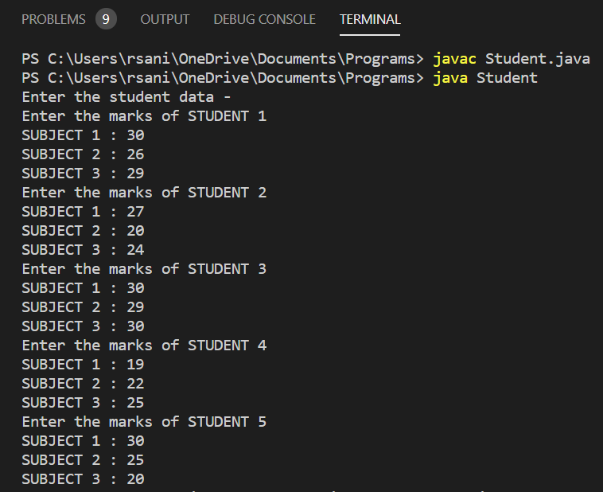

**Output:**

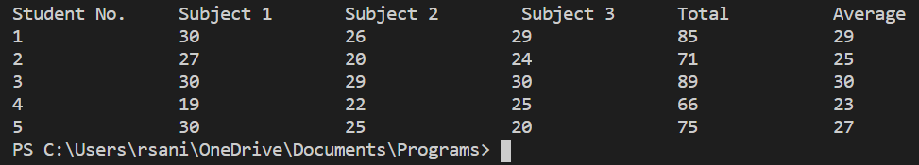

**CASE 2:**

**INPUT:**

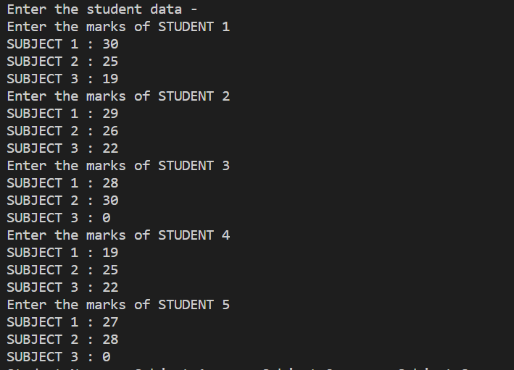

**OUTPUT:**

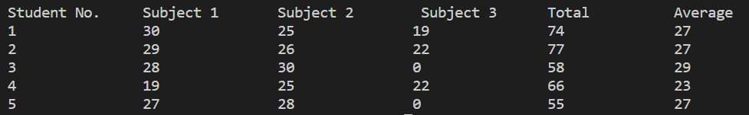

**Outcomes of the Experiment:** At the end of the laboratory sessions the students should be able to

1. Demonstrate the use of 2-D array in solving real-life problems.
2. Identify appropriate variables and their types
3. Identify appropriate looping constructs (for or do while)
4. Check if one loop will suffice or use nesting
5. Identify the control statements needed to meet the problem requirements.

**Conclusions:**  From the given problem statement, we could identify the necessary variables of appropriate type, and looping/control statements and the necessary program logic. The program was written in Visual Studio Code by creating a project. We understood the usage of the IDE in typing the code, debugging, running the program and observing the output. We also understood the use of the built-in class System and its method println to display the result. The program was executed for two-three sets of input and results obtained were verified to be correct and recorded.

**PRACTICE PROBLEM**

It is required to store and analyze data about 6 car manufacturer’s sales data in all the 12 months of a year. Demonstrate how you would store the data in a two-dimensional matrix and do the following

a. Write a method to find for a given car manufacturer, the month in which, maximum no. of cars are sold.

b. Write a method to find the average number of cars sold for each car manufacturer

c. Write a method to find the total number of cars sold for each car manufacturer.

Assume – row index 0 - ‘BMW’, 1 – ‘AUDI’, 2 – ‘LAMBORGHINI’ ,3-‘TESLA’, 4 – ‘HONDA’ 5 – ‘FERRARI’

col index 0 – ‘Jan’, 1- ‘Feb’………………………………….11 – ‘Dec’

Demonstrate the working of the program with appropriate values for each car manufacturer and the months.

**Program Source Code:**

import java.io.*;

import java.util.*;

import java.lang.*;

class Carsdata

{

    // given car manufacturer, the month in which, maximum no.of cars are sold.

    static int MaxCarsSold(String cars[], long data[][])

    {

        Scanner venki=new Scanner(System.in);

        String carManufacturer;

        int i,j,manufacturer=0,month=0;

        long max=-1;

        System.out.println("\nWe have the following car manufacturers");

        for(i=0;i<6;i++)

            System.out.print(cars[i]+" ");

            System.out.println("\nEnter the name of car manufacturer, to find out the month with highest sales :");

            carManufacturer=venki.nextLine();

            for(i=0;i<6;i++)

            {

                if(carManufacturer.equalsIgnoreCase(cars[i]))

                {

                    manufacturer = i;

                    break;

                }

            }

            for(j=0;j<12;j++)

            {

                if(data[manufacturer][j]>max)

                {

                    max = data[manufacturer][j];

                    month = j;

                }

            }

            System.out.println("The Maximum Cars sold by "+carManufacturer+" are in the month of: ");

            return month;

    }

    // method to find the average number of cars sold for each car manufacturer

    static void Average(long data[][], String car[])

    {

        double avg[]=new double[6];

        int i,j;

        long sum[]=new long[6];

        System.out.println("Average number of cars sold by each manufacturer");

        for(i=0;i<6;i++)

        {

            for(j=0;j<12;j++)

            {

                sum[i]+=data[i][j];

            }

            avg[i]=sum[i]/12;

        }

        for(i=0;i<6;i++)

        {

            System.out.println(car[i]+ " - "+avg[i]);

        }

    }

    //Write a method to find the total number of cars sold for each car manufacturer.

    static void Total(long data[][], String car[])

    {

        int i,j;

        long sum[]=new long[6];

        System.out.println("Total number of cars sold by each manufacturer");

        for(i=0;i<6;i++)

        {

            for(j=0;j<12;j++)

            {

                sum[i]+=data[i][j];

            }

        }

        for(i=0;i<6;i++)

        {

            System.out.println(car[i]+ " - "+sum[i]);

        }

    }

    public static void main(String []args)

    {

        Scanner venki=new Scanner(System.in);

        String cars[] = {"BMW", "AUDI", "LAMBOGHINI", "TESLA", "HONDA", "FERRARI"};

        String month[]={"January","February","March","April","May","June","July","August","September","October","November","December"};

        int i,j;

        long data[][]=new long[6][12];

        System.out.println("\n---------------------------------Welcome the Car Manufacturer's Sale Data---------------------------------");

        System.out.println("We have the following car manufacturers");

        for(i=0;i<6;i++)

            System.out.print(cars[i]+" ");

        System.out.println("\n\nEnter the following required data step by step -");

        for(i=0;i<6;i++)

        {

            System.out.println("Enter the number of cars sold by "+cars[i]+" in the month of - ");

            for(j=0;j<12;j++)

            {

                System.out.print(month[j]+": ");

                data[i][j]=venki.nextLong();

            }

        }

        int choice=0;

        do

        {

             System.out.print(month[MaxCarsSold(cars,data)]);

             System.out.println("\nPress 1 to check the data for other manufactureres or 0 to EXIT");

             choice = venki.nextInt();

        }while(choice!=0);

        System.out.println("\n----------------------------------------------------------------------------\n");

        Total(data,cars);

        System.out.println("\n----------------------------------------------------------------------------\n");

        Average(data,cars);

    }

}

// Programmed by Venkatesh D (flick_23)

**INPUT:**

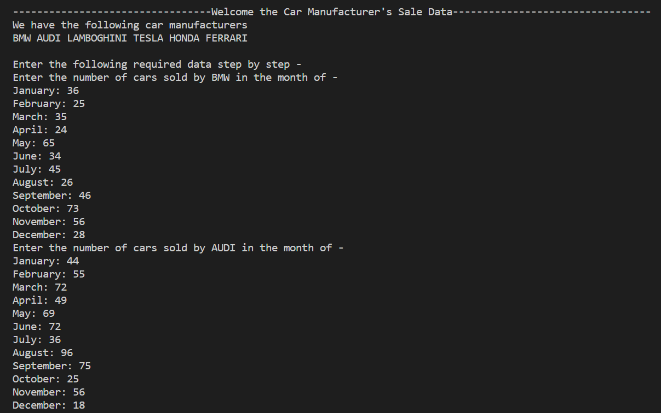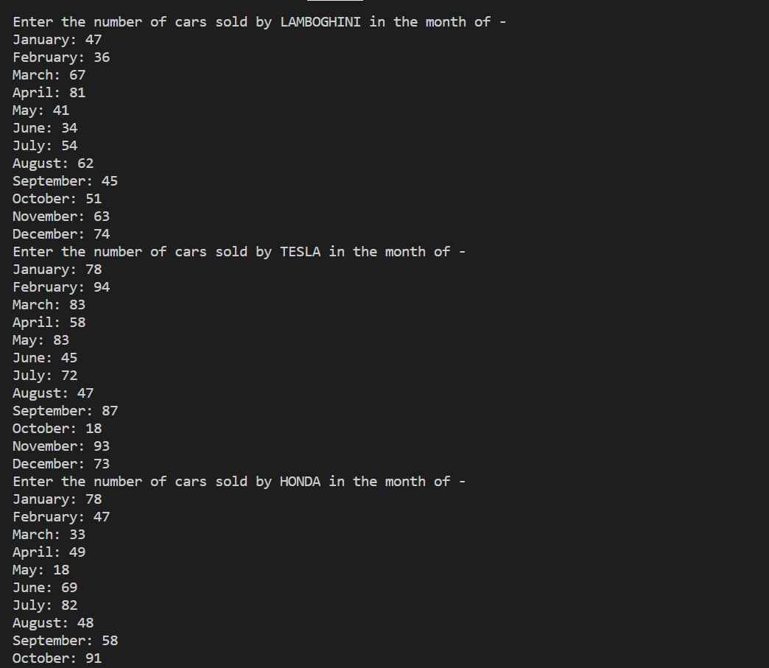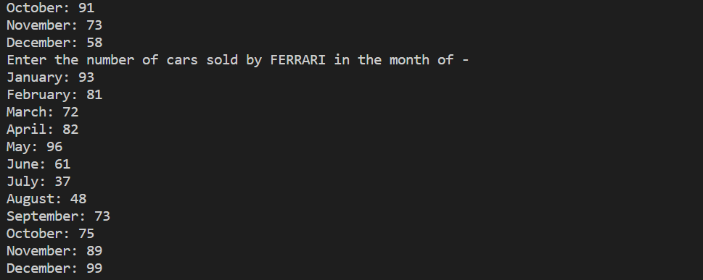

**OUTPUT:**

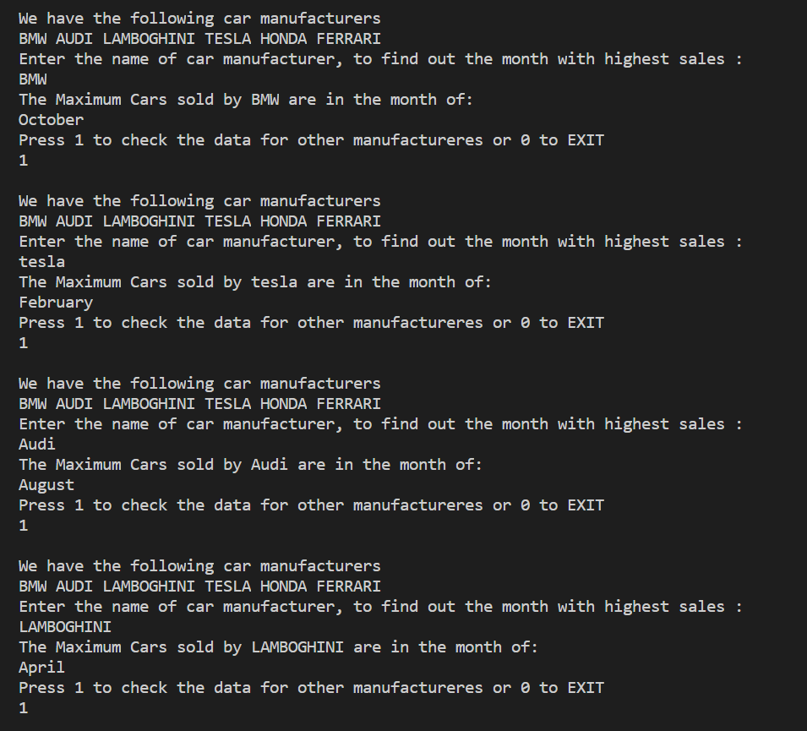

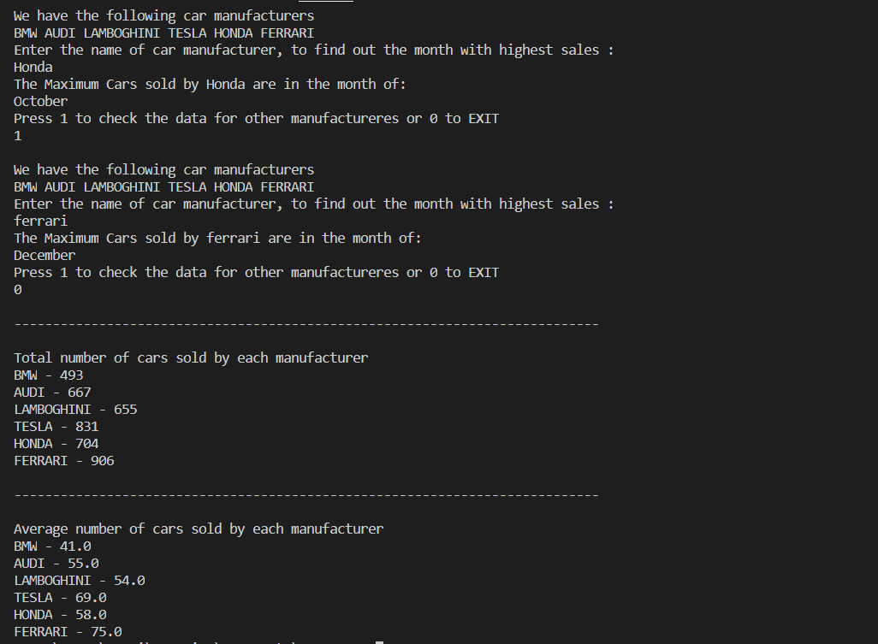

**CASE 2:**

**INPUT:**

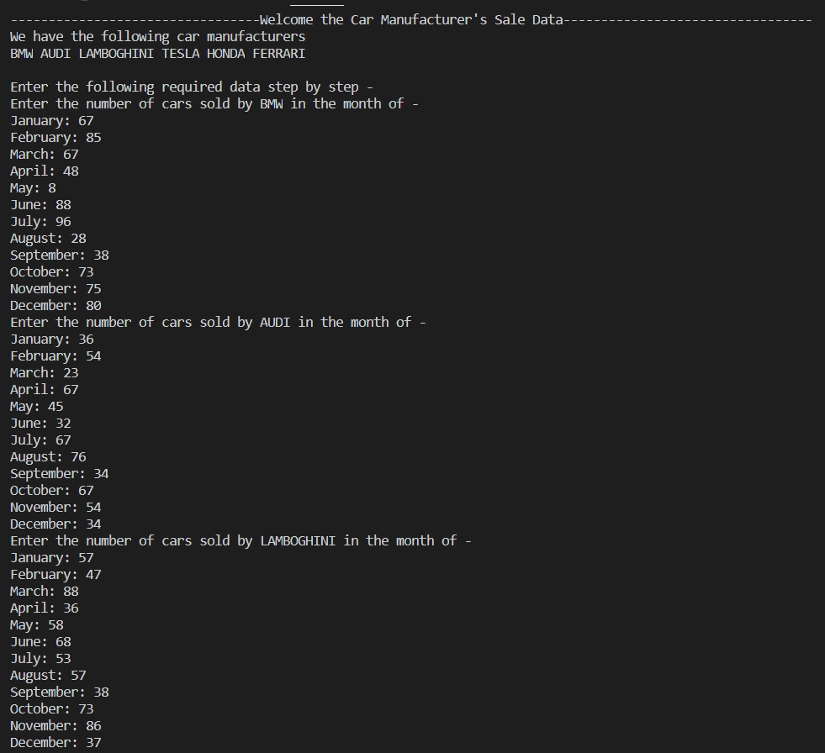 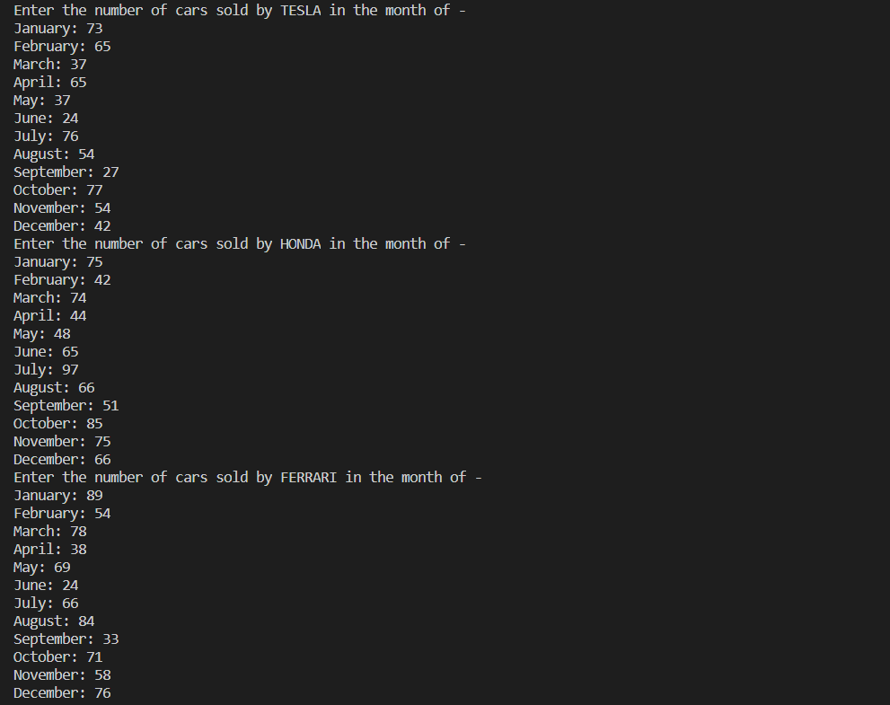

**OUTPUT:**

